Spring/Summer Inspection Guidelines (FRONT)
 |  | If the consignor rubber bands sizes together, please return the bins with the sizes rubber banded. | 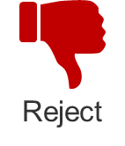 | With a red sharpie mark “S” for stain or you can write the reason such as holes or worn. Place all rejected items in a bag, write the consignor number and place the bag in the Return to consignor/ RTC bin. NOTE: If there is a black circle for donate, you can place those items that are rejected in the donate bin.
Shoes | - Clean with minimal to no wear  - Sneakers, sandals, flip flops, water shoes, open toe shoes, dress shoes, slippers and booties |  | - Dirty or excessive wear  - Boots - Do not write on the tag, tag can be used for next sale  - High heels/adult looking shoes
Costumes | - All pieces included; minimal wear |  | - Missing pieces; significant wear
Clothing/Coats/  (applies to all below) | - newborn to kid’s size 14/16 (no longer accept juniors)  - no stains - double check that the “stain” isn’t part of the design  - no holes or damage  - no pet hair or smell of smoke  - 1-2 like items per hanger (unless 3 piece set) |  | - Adult sizes or Brands; Outfits that are mismatched or do not have the same size; more than 2 items per hanger (unless 3 piece set)  - Any stains, holes, or damage such as missing buttons or broken zippers  - Anything that appears to be outdated, have excessive pet hair or smoke smell  - Any incorrect tag gun markings that could leave holes
Onesies | - All kinds allowed and in bag unless part of a set
Shirts/tops | - Short sleeve/Spring color long sleeve button up  - Spring/Summer sports team’s shirt/jersey  - Light weight/zip up hoodies with no drawstrings  - (Any holiday exceptions for spring) |  | - Long sleeve that are fall colors - Do not write on the tag, tag can be used for next sale
Pants/Bottoms | - Jeans accepted at both sales – some jeans have tears for style  - Shorts or cropped pants only  - Leggings  - Dress pants/Khaki pants |  | - Lula Roe will only be accepted in kids sizes
PJs/Sleepers/  Robes | - Sleepers size 0-18 months in a bag/all other sizes hung  - Short sleeved tops with long pants/shorts  - 3 pieces pajama set with pants and shorts |  | - Long sleeve pajamas with long pants - Do not write on the tag, tag can be used for next sale
Formal Wear | - Pageant wear, communion dresses, flower girl dresses, tuxedos, and suits
Maternity | - All seasons accepted |  | - Lula Roe is not considered maternity and it should be rejected
Undergarments | - Underwear if new in package  - Undershirts |  | - Underwear if NOT new in package
If you are finding more than 10 rejected items, please see Inspection area volunteer to talk to consignor.

Fall/Winter Inspection Guidelines
 |  | If the consignor rubber bands sizes together, please return the bins with the sizes rubber banded. |  | With a red sharpie mark “S” for stain or you can write the reason such as holes or worn. Place all rejected items in a bag, write the consignor number and place the bag in the Return to consignor/ RTC bin. NOTE: If there is a black circle for donate, you can place those items that are rejected in the donate bin.
Shoes | - Clean with minimal to no wear.  - Sneakers, boots, dress shoes, slippers and booties |  | - Dirty or excessive wear  - Summer shoes (sandals, flip flops, water shoes, open toes shoes) - Do not write on the tag, tag can be used for next sale  - High heels/adult looking shoes
Costumes | - All pieces included; minimal wear |  | - Missing pieces; significant wear
Clothing/Coats/  (applies to all below) | - newborn to kid’s size 14/16 (no longer accept juniors)  - no stains - double check that the “stain” isn’t part of the design  - no holes or damage  - no pet hair or smell of smoke  - 1-2 like items per hanger (unless 3-piece set)  - 2 shirts or 2 pants per hanger |  | - Adult sizes or Brands; Outfits that are mismatched or do not have the same size; more than 2 items per hanger (unless 3-piece set)  - Any stains, holes, or damage such as missing buttons or broken zippers  - Anything that appears to be outdated, have excessive pet hair or smoke smell  - Any incorrect tag gun markings that could leave holes
Onesies | - All kinds allowed and in bag unless part of a set |  | - Any stains, holes, or damage
Shirts/tops | - Long sleeve only  - Short sleeve exception: Polos; Holiday shirt (Halloween, Christmas, Valentines and St Patrick’s Day) or Fall/Winter sports team’s shirt/jersey |  | - Short sleeve - Do not write on the tag, tag can be used for next sale
Pants/Bottoms | - Jeans accepted at both sales – some jeans have tears for style  - Long Pants |  | - Shorts/Cropped Pants - Do not write on the tag, tag can be used for next sale  - Lula Roe will only be accepted in kid’s sizes
PJs/Sleepers/  Robes | - Sleepers size 0-18 months in a bag/all other sizes hung  - Short sleeved tops with long pants  - 3 pieces pajama set with pants and shorts |  | - 2-piece short sleeve and shorts
Formal Wear | - infant sizes to juniors  - pageant wear, communion dresses, flower girl dresses, tuxedos, and suits
Maternity | - All seasons accepted |  | - Lula Roe is not considered maternity and it should be rejected
Undergarments | - Underwear if new in package  - Undershirts |  | - Underwear if NOT new in package
If you are finding more than 10 rejected items, please see Inspection area volunteer to talk to consignor.

TAGGING GUN GUIDELINES  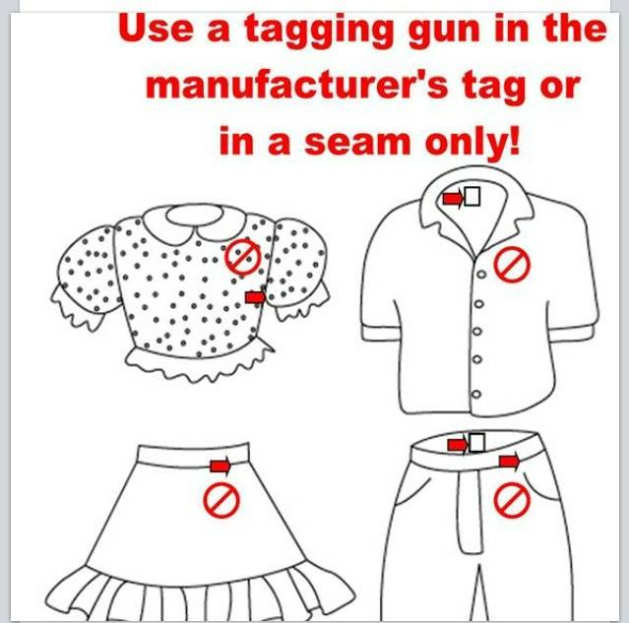 | - Accept – Any item that is tagged using a tagging gun in the seam or in the manufacturer’s tag.  - Reject – Any item that is not tagged using a tagging gun in the seam or in the manufacturer’s tag. Refer to Inspection area volunteer or Sonia if you are finding this.
DVD / CD / Video Game Inspection Guidelines | Accept:  - DVD / CD/ Video game disc must be an original  - DVD / CD/ Video game disc must match the case and the tag  Reject:  - DVD / CD/ Video games that are counterfeit or non-original (copies)  - DVD / CD/ Video game disc does not match the case
TOYS / GAMES / PUZZLES Inspection Guidelines | Reject:  - No Batteries or Corroded Batteries  - Missing pieces or parts  - Stuffed animals (unless animated)

